|  |
| --- |
|  |
| November 2020 |
|  |

Florenceville Middle School



# Upcoming Events

**November 2020**

4th – Newsletter

11th – No School (Remembrance Day)

13th – Picture Day!

20th – PL Day – NO SCHOOL

**December 2020**

1st – Report Cards Issued

2nd – Newsletter

3rd – Parent Teacher Interviews (evening)

4th – Parent Teacher Interviews (morning)

18th – Last Day before Christmas break!

December 21st – 31st – Christmas Holidays

|  |
| --- |
|  |
| Sports Teams Cross country has come to an end, and we have begun badminton! Practice times are as follows:  Grade 6: Thursday’s, 3-4:15  Grade 7: Monday’s 3 – 4:15  Grade 8: Wednesday’s 3 – 4:15  More info regarding the changes to badminton will be sent home with those who attend practices. |

8794 Main Street, Florenceville-Bristol, NB E7L-3G2

FMS.nbed.nb.ca 506-392-5115

|  |
| --- |
|  |
| It is hard to believe that November is already here! Before we know it, the playground will be filled with snow. Report cards are just around the corner too!  We continue to navigate through the changes to our daily routines and are always reminding students to be safe and practice good hygiene. We also have been working to develop their social emotional skills using the Character Strong program.  We appreciate your continued support!  Ms. Rioux, Ms. Pearson, and the FMS Staff |
|  |

## **Contact Information**

Please continue to inform the school of changes to your contact information. If you have a change in email address or phone number, it is important that you keep us updated by calling Sally at 392-5115 or by sending in a note to the homeroom teacher.

If you no longer require a personal phone call in the event of an early closure, please let Sally know. The more up-to-date data we have, the quicker we can organize students in the event that school does need to close early.

## Important reminders

As mentioned in previous Newsletters, emails, and talkmails, keeping track of 180+ students makes the office a very busy place! Here are a few safety highlights:

* If you know that your child is being picked up or is staying for an afterschool activity, please send a note in for the homeroom teacher rather than calling the office. For your child’s safety, we need to have these things taken care of early in the day.

Reminder: All Students will be spending time outside this winter and will require full winter gear. Students will be expected to remain outside for the full noon hour during the winter, **this is a must**! Proper Indoor/Outdoor Boots/shoes are also a must!

* If your child is staying for a repeating activity, one note that indicates permission to stay any day there is the activity will work.
* Students are not to walk off campus unless they are walking home – and they must live within walking distance.
* Students are not allowed to travel on other buses – and any change to busing must go through district transportation. Permanent changes need to be made 4 weeks in advance.

Many thanks!

## Keeping safe

Just a few reminders about how we can keep safe and healthy here at FMS:

* Students are required to have 2 masks with them daily and must wear their masks while on the bus as well as when travelling throughout the school building.
* Have a backup plan – if your child becomes ill during the school day, they MUST be picked up within the hour. Call 811 for direction if they have 2 or more symptoms of Covid-19.
* Please keep your child at home if they are feeling unwell.

## **School Closures: Weather Conditions**

Anglophone West School District is committed to the safe and efficient transportation of students. The district recognizes it may be necessary to cancel bus runs, close schools, or delay school opening to ensure students are not endangered by hazards brought on by poor weather and road conditions.

Options Considered:

* **Schools are open as usual:** no communication required.
* **All schools closed for the day:** see “Communication” section below.
* **A school or schools in a particular zone of the district closed:** see “Communication” section below.
* **All school bus routes delayed by one hour:** On these occasions, all schools in the district will open at their regular time to receive walking students and students normally dropped off. Students arriving late will not be disadvantaged.
* **Schools may be closed early** on days when it is anticipated that weather conditions may deteriorate significantly. It is important that parents have alternate arrangements for their children if they or another adult will not be home to receive students. It will be announced that buses will run their afternoon one, two, or three hours earlier than usual.
* **Power Outage:** School will be opened at the regular time unless otherwise communicated by the superintendent.

**Communication**: Announcements will be made on local radio stations through a recorded message that can be heard by dialing the district information line at 1-888-388-4455 any time after 6am and by checking the district website at [www.asd-w.nbed.nb.ca](http://www.asd-w.nbed.nb.ca). We will also do our best to post on the FMS Home and School Facebook page, as well as twitter!

**School Zone:** FMS is in school zone **3**.

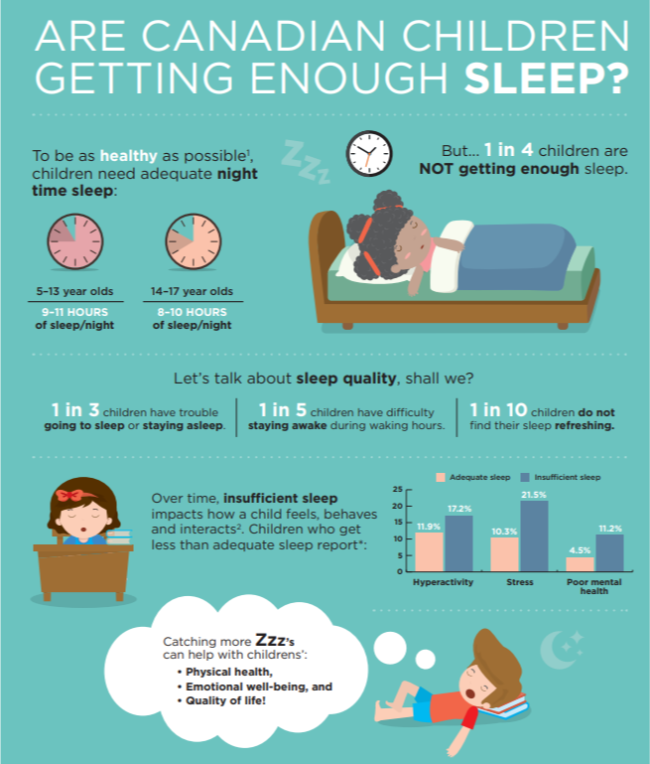IMPORTANT: In the event of a closure after school has opened, parents who have indicated that they need a personal phone call will be contacted. In these circumstances, we must have your up to date contact information as we cannot release students until this contact has been made.

Don’t forget!

You can order lunches through cafzone.ca (our preferred method) or you can use cash and order at the beginning of the week for the full week. Please understand that we cannot do daily orders for all students.

Parent Teacher

Report cards for first term will be issued on December 1st, 2020. Parent teacher interviews will be held on the evening of December 3rd and the morning of December 4th.

Due to Covid-19 restrictions, parent teacher interviews will be held either by phone or virtually using Microsoft Teams. When you call to book an appointment, you can request either a call back (you will provide the phone number) or teams meeting (we will send you an invite). More information will be coming home regarding when to book parent teacher interviews, so please be watching!

